**Project Time Management**

**Schedule Management Plan**

Here is the screenshot of Gantt chart of our project:

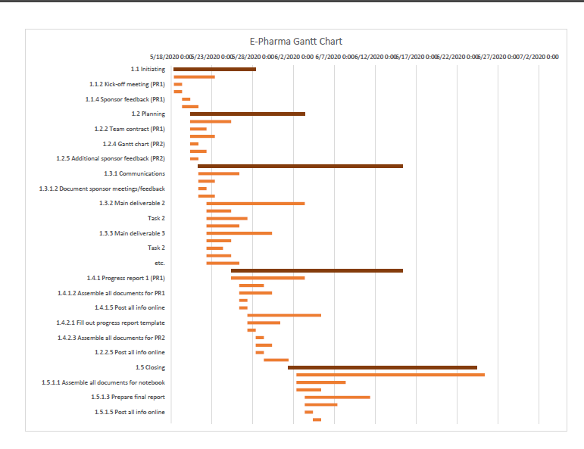

Gantt chart file is attached with the document